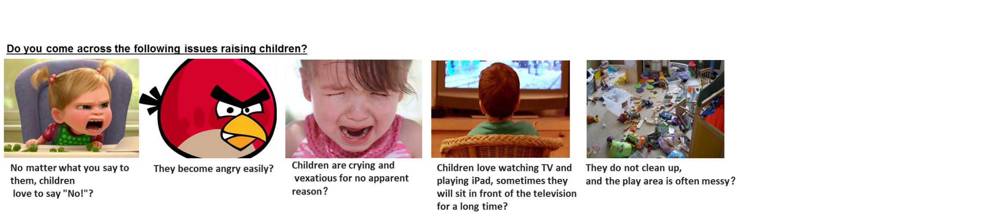
If so, then please be assured that these scenarios are not unique to your family!
They are happening every day all the time on the global scale.
Create a Positive mind set for parenting! Attend the Positive Discipline (P.D.) Parent Education Seminars

Dates:
Sat. Nov. 7, Nov. 21, Dec. 5: 1-2:30pm
Thurs. Dec. 17: 7-8:30pm
Sat. Jan. 7, 23, Feb.6, March 6: 1-2:30pm
Thurs. March 25: 7-8:30pm

What is Positive Discipline?
- Kind and firm child-rearing method
- Respect both child and parents
- Developed 40 years ago and famous world wide
- Based on "individual psychology" theory of Alfred Adler
- Help parents solve daily challenges

Facilitators
Location: Your home via
ZOOM webinar
Jieying Li, MS
- Certified Positive Discipline Parent Educator
- Certified Positive Discipline Teacher Educator
- Parent Effectiveness Training Trainer
Cost: $175, includes PD materials (workbook, book, parenting cards)
- Neuro-Linguistic Programming Practitioner
Chiti Kompella
- Certified Positive Discipline Parent Educator
- Certified Positive Discipline Teacher Educator
- Certified Montessori Teacher
Joan Heiting, M BS,
- Masters in Behavioral Science with specialty in counseling organizational development
- Founded & consulted with multiple Montessori schools across the state
- Founding member of Pacific Northwest Montessori Association
Registration Form
Please complete the registration form on Google doc at this link:
https://docs.google.com/forms/d/e/1FAIpQLSeeBDwEflt5Y3Nn4Vii-GxCwFsf8RUMQY3XjJae4WlqCLNlDg/viewform?vc=0&c=0&w=1&flr=0

Workshop Elements: Discussion, Q & A, Parents helping parents, Role Play, Reading,

*This is a 9 part series for parent education supporting a lifelong journey for children and parents in communication, problem solving, connection, and more.

